How big is the force?

There is one force-arrow for each force.
Which force-arrow shows the force needed to lift my cat?

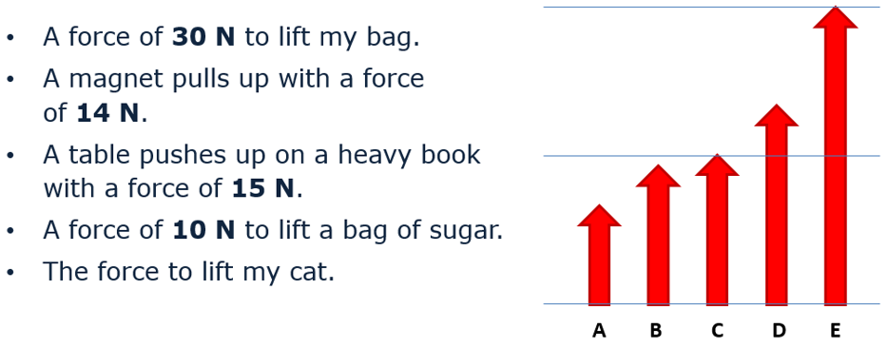

- Which force-arrow shows the force needed to lift my cat?
Put a tick (✓) in the box next to the correct answer.
A |  |  |  | D
B |  |  |  | E
C

- What force is needed to lift my cat?
Put a tick (✓) in the box next to the correct answer.
A | 6 N
B | 20 N
C | 23 N
D | 50 N

Physics > Big idea PFM: Forces and motion > Topic PFM1 Forces > Key concept PFM1.2: Describing forces
Diagnostic question
How big is the force?

Overview
Learning focus: | Forces arise when two objects interact; the force on one object is always equal in size, and opposite in direction to the force on the other object; force arrows indicate the size, direction and location of each force.
Observable learning outcome: | Represent the size and direction of a force with an appropriate force arrow.
Question type: | Two-tier multiple choice
Key words: | Force, force arrow, Newton

What does the research say?
Some students find it hard to think of forces in terms of their magnitude and direction (Driver et al, 1994). Terry et al (1985) found that many 11-14 year old students were quite ad hoc in their use of force arrows: they did not effectively start them from the point of action, use them to indicate the direction of force or change their length to indicate the size of the force.
Drawing force-arrows to scale or interpreting relative sizes of forces from their lengths requires mathematical skills that some students will find difficult and which are not necessarily taught in mathematics lessons until age 12-13 (Boohan, 2016).
It is important not to assume that all students will be able to draw or interpret force arrows without practice, and it may be appropriate to choose simple scales to instil the scientific concept more clearly at this stage.
Ways to use this question
Students should complete the questions individually. This could be a pencil and paper exercise, or you could use an electronic ‘voting system’ or mini white boards and the PowerPoint presentation. The follow on question will give you insights into how they are thinking and highlight specific misunderstandings that some may hold.
If there is a range of answers, you may choose to respond through structured class discussion. Ask one student to explain why they gave the answer they did; ask another student to explain why they agree with them; ask another to explain why they disagree, and so on. This sort of discussion gives students the opportunity to explore their thinking and for you to really understand their learning needs.
Differentiation
You may choose to read the questions to the class, so that everyone can focus on the science. In some situations it may be more appropriate for a teaching assistant to read for one or two students.

Expected answers
a. D b. B
How to respond - what next?
Forces B and C must be 14 N and 15 N as they are very close. E is about twice as long, so it is 30 N and A is shorter so it is 10 N. This leaves D which is the force to lift the cat. Force-arrow D is closer to 15 N (C) than it is to 30 N (E) – so it is 20 N.
If students are simply putting the forces in order of size then they may choose a random force-arrow and make an educated guess of the force needed to lift a cat.
If they rightly identify D as the correct force-arrow, they are likely to have recognised that two very similar forces (14 N, and 15 N) will be represented by two very similar force arrows.
Choosing the size of force D as 20 N also shows understanding of the proportional sizes of the force-arrows.
If students have difficulty in thinking about the relative lengths of force-arrows, a suitable response might be to give them the opportunity to practise drawing force arrows to scale, such as those shown on the last slide of the PowerPoint for this question. The values chosen on this slide allow fairly simple scales of 1mm (or 2 mm) per Newton to be used.
The following BEST ‘response activity’ could also be used in follow-up to this diagnostic question:
- Response activity: Measuring forces
Acknowledgments
Developed by Peter Fairhurst (UYSEG).
Images: UYSEG
References
Boohan, R. (2016) The language of mathematics in science, Association for Science Education, Hatfield, England.
Driver, R., Squires, A., Rushworth, P. and Wood-Robinson, V. (1994) Making sense of secondary science, research into children’s ideas, Routledge, London, England.
Terry, C., Jones, G. and Hurford, W. (1985) ‘Children’s conceptual understanding for force and equilibrium’, Physics Education 20(4): 162-5.

